***NAME :: IBRAR BABAR***

**Roll no :: 19P-0104**

**BS(Computer Science)**

**DLD LAB :: SECTION ( 2B2 )**

***SIR YOUSAF***

1. BCD to Gray Code Conversion

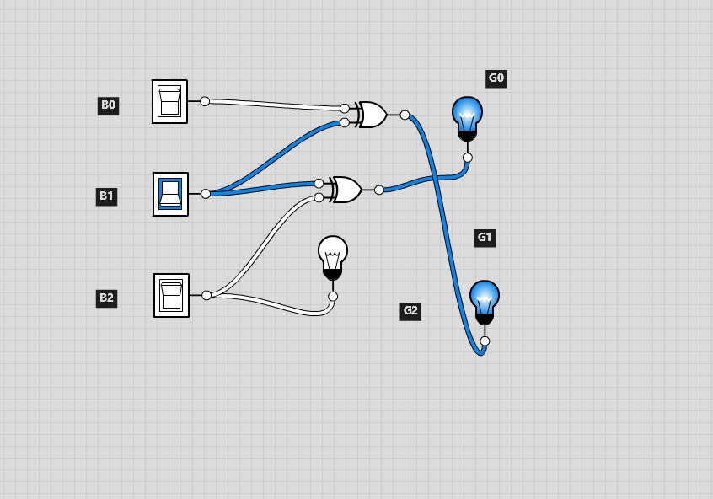

2. BCD to Excess-3 code Conversion

